fdfdfsdg
 **Pakistani cuisine-**

**Rich in Tradition, Full of Marvelous and Diverse Dishes**

**Best Pakistani Dishes You Must Try**

**food blogger visited Pakistan**

**Pakistani food that mesmerized foreigners**

**What so famous about Pakistani food**

**Pakistani beverages & Snacks**

**Nothing is More Delicious then a Pakistani Food.**

**Spiced Biryani & Korma Recipe**

**Pakistani Food Famous Provinces Food**

**Famous Pakistani Chefs**

**Famous Pakistani Traditional Restaurant**

**© Zobia,Kainat.K,Wajia,Sidra,S.Kainat**

Contents

About 3

Pakistan Cuisine Details 4

Foreigner Mesmerized by Pakistani Cuisine 5

Here Are the Reasons Why the World Loves Pakistani Food Culture! 5

Best Pakistani Dishes Everyone Must Try 6

Biryani 6

Chicken Tikka 6

Kabab 7

Channa Chaat 7

Sajji 8

Haleem 8

Nihari 9

Halwa Puri 9

Kheer 9

Food in different Provinces of Pakistan 10

Food In Punjab 11

Food In Sindh 11

Food In KPK 12

Food In Baluchistan 12

Food In Gilgit Baltistan 13

Food In Azad Kashmir 13

Famous Food Vloggers visited Pakistan 14

# About

Magazine is Created By Zobia Khalid 3355, Syeda Wajiha Zahra 3277, Kainat Kausar 3682, Sidra Rehman Afridi 3866 & Syeda Kainat 3256.

Our Magazine is about Pakistan Cuisine. About its Diversity, Popularity and about its Taste that mesmerized people of any Country.  
There will be Famous Restaurant Suggestions, Foods and street foods.

# Pakistan Cuisine Details

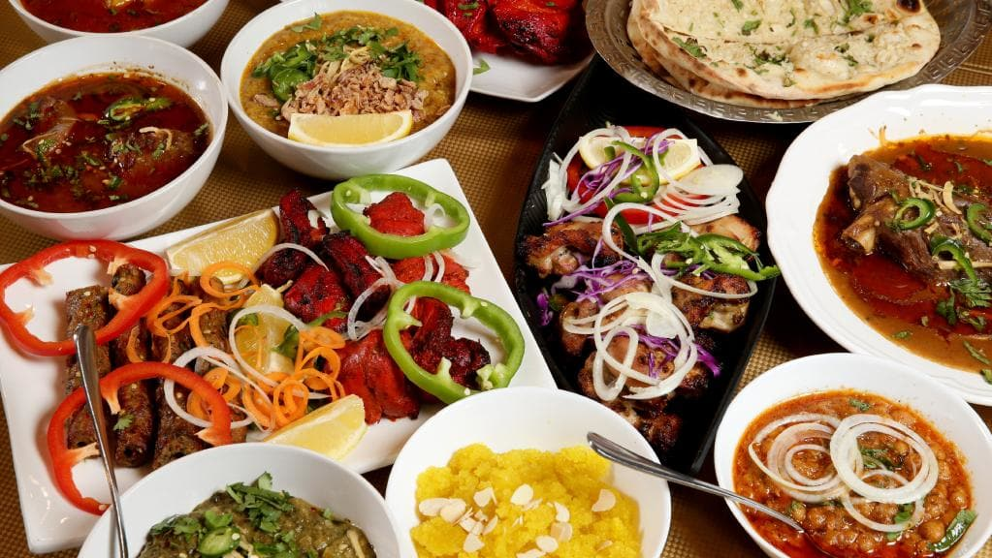**Pakistan has some of the most diverse and flavorful recipes in the world due to the infinite amount of special herbs and spices available, and each traditional dish comes with a deep history that connects it to a particular province. The versatile geography, ranging from deserts to the world’s highest mountain peaks, creates a wide variety of different types of recipes, each with a unique taste**

**Pakistani Food is Rich in Taste and its cultural Diversity. There are Varity of Food That are not only Famous in Pakistan but Foreigners also love them.**

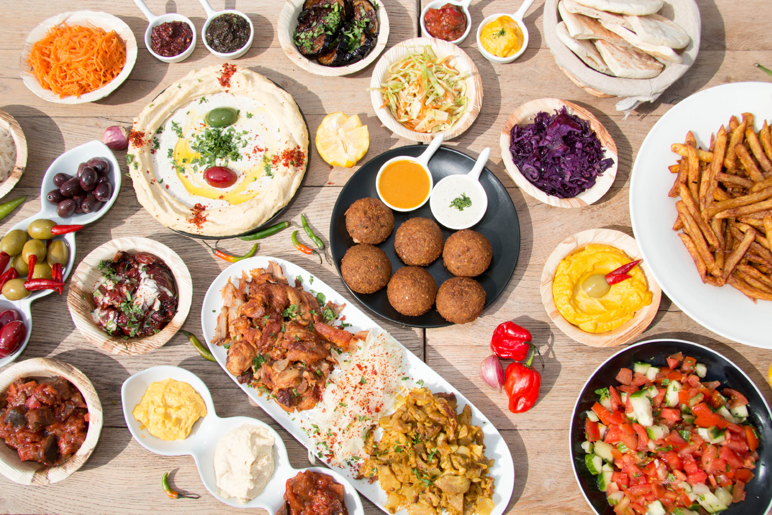**Pakistani Cuisine also known as Desi Food.  
There are Varity of Food that are Famous.**

* **Biryani / Pulao**
* **Kababs , Quorma / Karahi**
* **Vegetables & Beans**
* **Seeji, Steam & Dum Pukht**
* **Desserts.Tea & Drink**

# Foreigner Mesmerized by Pakistani Cuisine

## Here Are the Reasons Why the World Loves Pakistani Food Culture!

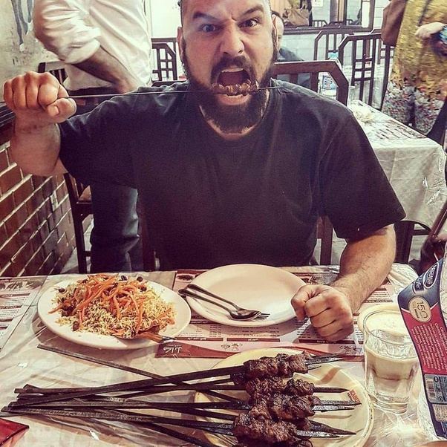**Pakistan is a country with a lot of different cultures and people. With that brings an amalgamation of wonderful clothing, dance, songs, jokes, traditions and of course food. Pakistani food culture is unique each place has their own twist to the same dishes. Whilst also having completely different dishes as well.**

**Food is like a religion in Pakistan, with places open up till 3:00 am in the morning you can pretty much get anything you want at any time. Every city in Pakistan has its own dishes which they are known for. More so, even certain areas of the city are known for separate dishes. Not just the cities, but the villages also have their own food culture.**

**Pakistani food culture is so deep and hard to explain. I think that I can write a full 300-page book on it and it still won’t do it justice. I will try my best to summarize the Pakistani food culture in this short article to the best of my abilities.**

**The simple food culture of Pakistan revolves around street food, dine in food and take away foods.**

# Best Pakistani Dishes Everyone Must Try

**All Pakistani Foods Are Tasty and Delicious but most liking Food of Pakistan which are like by Everyone are listed Below:**

## Biryani

**Biryani is a mixture of delicious yellow rice and either chicken or beef. The rice gets its color from an assortment of spices and herbs, which also adds an incredible flavor. To top it off, it contains perfectly cooked lemons, tomatoes, and potatoes.**

**There are many Kind of Biryani which are cooked at different region of Pakistan.**

**Most Famous are Karachi Biryani, Sindhi Biryani, Aloo Biryani.**

## Chicken Tikka

**Chicken tikka is one of the most popular foods in Pakistan, both for its taste and its nutritional value—that is if it is not accompanied by “naan.” It is a sizable portion of chicken slathered in traditional spices and then grilled to perfection. For the ultimate experience, dip the pieces of chicken in the accompanying mint dressing.**

**Tikka’s are also the well-known food of Pakistan. In Tikka’s there are also Chicken Malai Tikka, Chicken Paneer Tikka.**

## Kabab

**Kababs usually feature well-seasoned beef. The grilling method used to cook them gives them a succulent quality. Pair them with some herb-infused rice—you won’t be disappointed.**

**There are different varieties of Kababs cooked in different region in Pakistan. Seekh Kabab, Chicken Kabab, Chappali Kabab, Taj Kabab, Mughali Kabab, Kache Keema ke Kabab, Beef Sheesh Kabab, Aloo kay Kabab.**

## Channa Chaat

**“Channa” means chickpeas, and it is one of the most-loved snacks in Pakistan. In this tasty light dish, chickpeas are mixed with various vegetables, such as tomatoes and onions, and topped with a dressing that creates a bittersweet-eating experience.**

**Dhain Bharay is also like Channa Chat and Famous snacks in Pakistan. Dhain Bharay are made of dhain, bondiyan, bhalay, tomato, onions.**

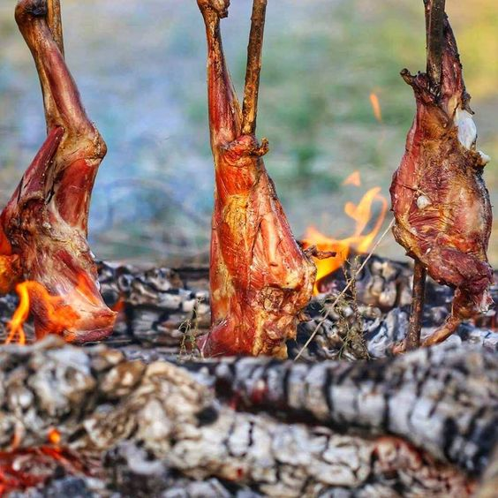

## Sajji

**Sajji is a dish that can attribute its origins to the province of Baluchistan. It is one of the primary specialties of Pakistani traditional cuisine and consists of a large piece of either lamb or chicken stuffed with rice and topped with a tasty green papaya paste. It’s then placed on a skewer and roasted for several hours. But this Baloch delicacy is now a favorite among meat lovers all over the country and outside Baluchistan.**

**In the original recipe, the lamb or chicken is hollowed out and stuffed with potatoes and rice. The meat is cooked without any spices or oil as it is allowed to tenderize in its own juices. Only salt is added for flavor.**

## Haleem

**Haleem is a mixture of a variety of traditional staples used in Pakistani cuisine, such as wheat, barley, minced beef, mutton or chicken. It is a dish that takes a long time to prepare because the lentils and special spices need ample time to properly combine with the minced beef and create a unique paste that will delight the senses.**

**Haleem is a type of stew popular in the Middle East, Central Asia. The dish varies from region to region.**

## Nihari

**Nihari is one of the most famous stews in the entire country. It is served to guests on important occasions and contains meat that is slow cooked and simmered in spices overnight. The cooking process allows the dish to absorb the flavorful bone marrow fully, creating one of the best-tasting meat dishes in the world.  
Nihari, is a stew from Pakistani region consisting of slow-cooked meat mainly shank meat of beef or lamb and mutton, goat meat and chicken, along with bone marrow.**

## Halwa Puri

**A puri is a type of dough sprinkled with salt and rolled out in a circular form that is then fried in a small amount of oil. It is extremely fluffy and light and comes with a sweet dish called halva—a combination of sugar syrup, egg whites, and sesame seeds which are locally known as (cholay or channay).**

**The mixture of sweet and sour flavors results in a memorable dining experience.**

**The origin of Halwa Puri is said to be Uttar Pradesh, India but it is widely eaten and known as one of the most popular Pakistani dishes.**

## Kheer

**Kheer is the most famous traditional dessert in the country. It is a rice pudding by boiling milk and sugar with one of the following: rice, broken wheat, tapioca, vermicelli, or sweet corn. It combines an assortment of nuts, such as almonds, pistachios, and cashews, as well as saffron and cardamom to give it an alluring tinge that melts in your mouth with each bite.**

# Food in different Provinces of Pakistan

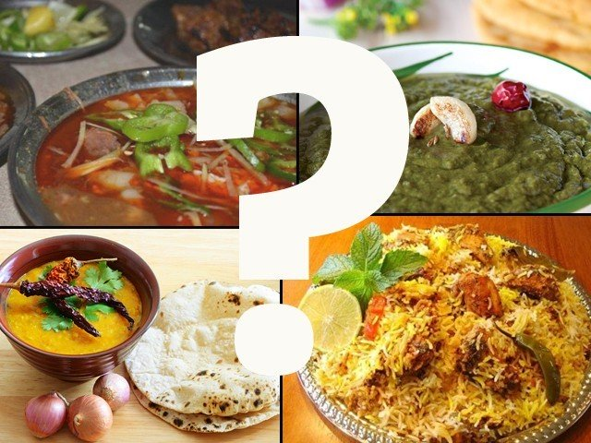There is definitely no love sincerer than the love of food, when everyone else may leave you just know that food never will. While some people eat to live, most Pakistanis live to eat. Only in Pakistan would you find everyone saying how their mother is the best cook in the world, and no doubt that comes from the love for food we have rooted deep within.

Also, Pakistani food is NOT the same as Indian food. Yes, we have our similarities but the way it tastes to the way it’s cooked is really different (we don’t have anything known as *read in an American accent* Chicken Tikka Masala – it’s just Tikka bro). Although yes, our food recipes are a blend of most of the countries that we are surrounded by such as central Asia, the Middle East and specially the Mughlai cuisine. Since Pakistan is such a diverse country with diverse cultures the traditional foods vary from region to region.

While KPK is all about that meat, Punjabis get their B.B.Q and Karahi on, the Balochis have blessed us with their Sajji and the Sindhis gave us their Sindhi Biryani. Here is a guide to let you know where the foods that we love so much originate from.

In Pakistan Each Cities , Each Provinces are Famous for their own traditional Food.

## Food In Punjab

* **Keema**
* **Batair**
* **Tikka/Kebab**
* **Shami Kabab**
* **Gosht**
* **Karahi**
* **Biryani**
* **Khichri**
* **Sarson Ka Saag**
* **Naan / Paratha / Roti**
* **Halwa Puri**
* **Lasi**
* **Chai**
* **Qeema**

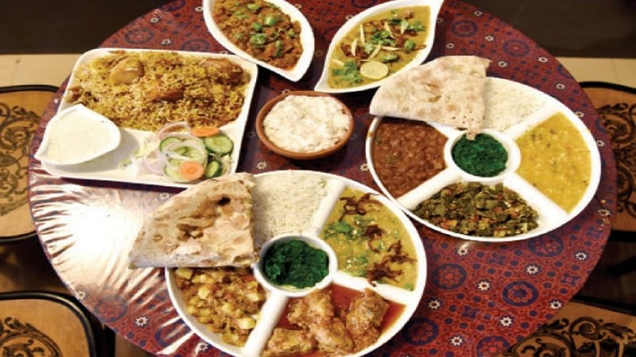

## Food In Sindh

* Sai bhaji chawal
* Koki
* Seviyan
* Mitho lolo
* Taryal Patata
* Pallo Machi
* Thadal
* Sindhi Biryani
* Fish
* Other Sea Foods
* Taryal Patata
* Palli
* Thadai
* Khirni
* Sharbat
* Falooda

## Food In KPK

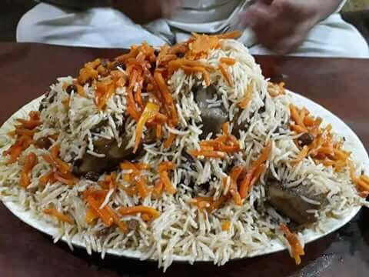

* Chappli Kebab
* Kabuli Pulao
* Shinwari
* Kabab/Tikka
* Kahwa
* Dumba/lamb karahi
* Mantu
* Naan (Doday)
* Bonjan
* Londei, (spiced lamb jerky cooked with rice)
* Charsi Tikka
* Shorwa (soup)
* Aush (hand made noodles)
* Aushak
* Bendei, okra cooked in oil with onions and tomatoes
* Masteh (freshly made yogurt)

## Food In Baluchistan

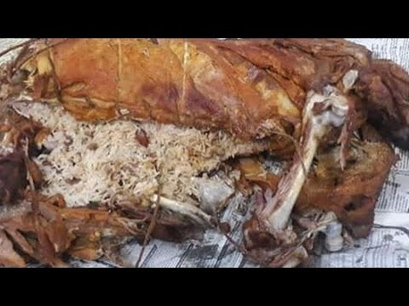

* Khadi Kabab
* Sajji
* Kaak
* Dumpukht
* Lahandi
* Khaadi Kabab
* Abgoosht
* Khrud
* Chilaanch
* Roosh
* Tereeth
* Butt o Maash

## Food In Gilgit Baltistan

* 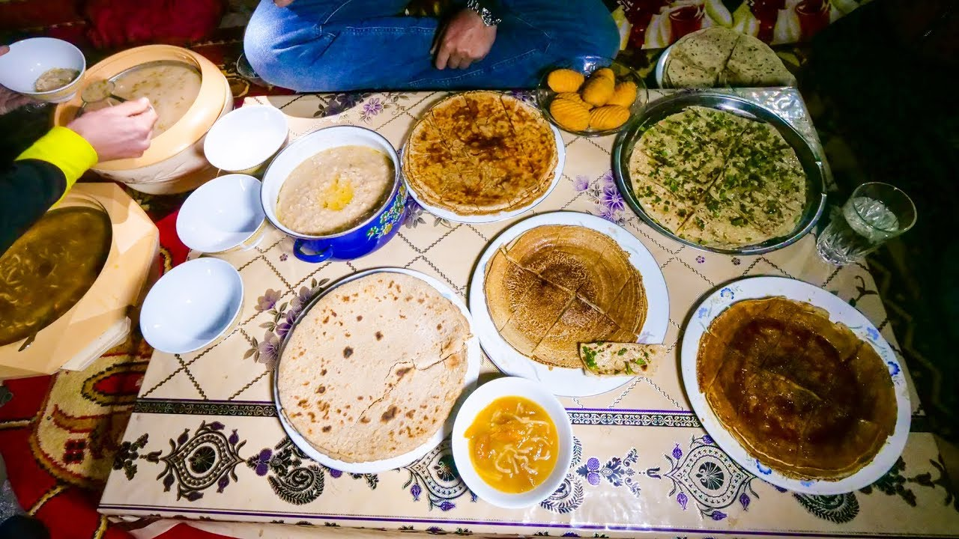**Balay (Noodle Soup w/Goat Meat)**
* **Prapu (Wheat Noodles w/Walnut Paste)**
* **Gyal (Buckwheat Cakes)**
* **Marzan (Buckwheat with Apricot Oil)**
* **Boiled Goat (skinless)**
* **Potato Stew (w/Goat Meat)**
* **Butter Tea (served w/Buckwheat Flour)**
* **Chapshuro**
* **Mamtu**
* **Harissa**
* **Sharadi**
* **Gooli**
* **Diram**

## Food In Azad Kashmir

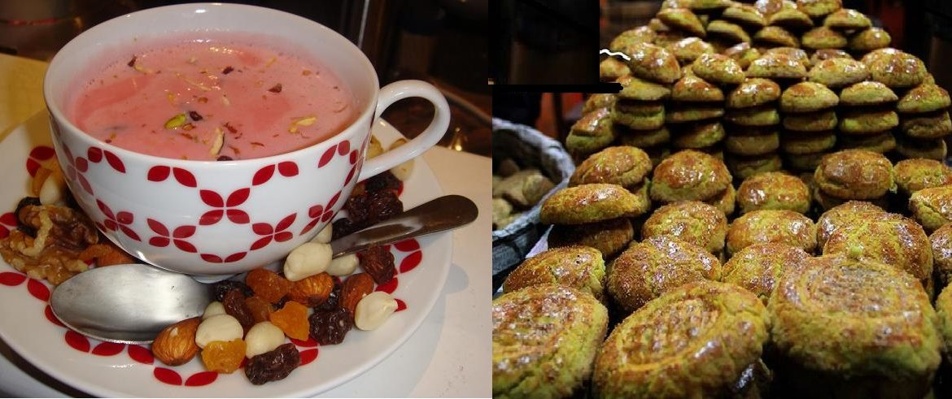

* **ROGAN E JOSH**
* **MODUR PULAV**
* **MATSCHGAND**
* **YOGHURT LAMB CURRY**
* **DUM OLAV**
* **KASHMIRI MUJI GAAD**
* **AAB GOSHT**
* **GOSHTABA**
* **LYODUR TSCHAMAN**
* **MOMOS**
* **Kashmiri Chai**

# Famous Food Vloggers visited Pakistan

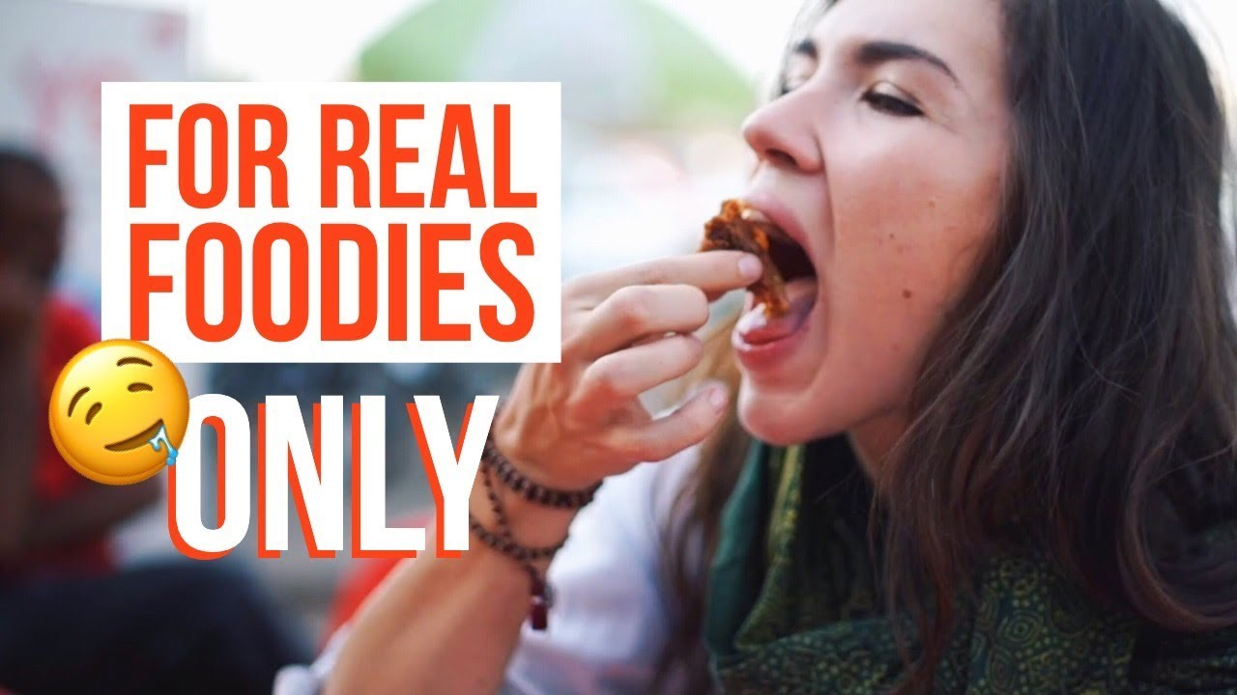

**There are Numbers of Food Vloggers running their YouTube channels on Food visited Pakistan.**

**Eva Zu Bek is a travel blogger, who has roamed almost 44 countries till now. There are not many female bloggers around, let alone being this free-spirited and full of life.**

**Eva when she came to Pakistan after visiting China and Mongolia. She was instantly everywhere on Pakistani Instagram newsfeed.**

**She was also mesmerized by Pakistani Food. She fell in love with Pakistani Chai and Biryani and Street food which sales besides each street in Pakistan.**

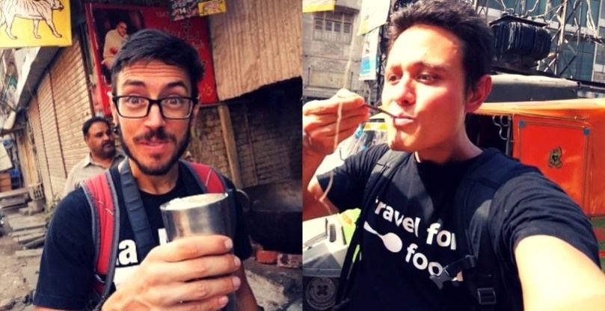

**Mark Wiens, the food blogger made a 16-day food journey to Pakistan, visiting the diverse landscape from Lahore to Gilgit Baltistan in his quest to taste the exquisite food. He along his journey met the most welcoming populous who always met him with a warm smile sharing not only their food but guiding him to the tastiest treats around town.**

**Mark went from Lahore to Gujranwala, Chakwal, Islamabad, Peshawar and in the North visited Peshawar, Gilgit Baltistan and Karachi. He tasted the karahis, the payaz to the nihari’s and the street food that each city deems special.**

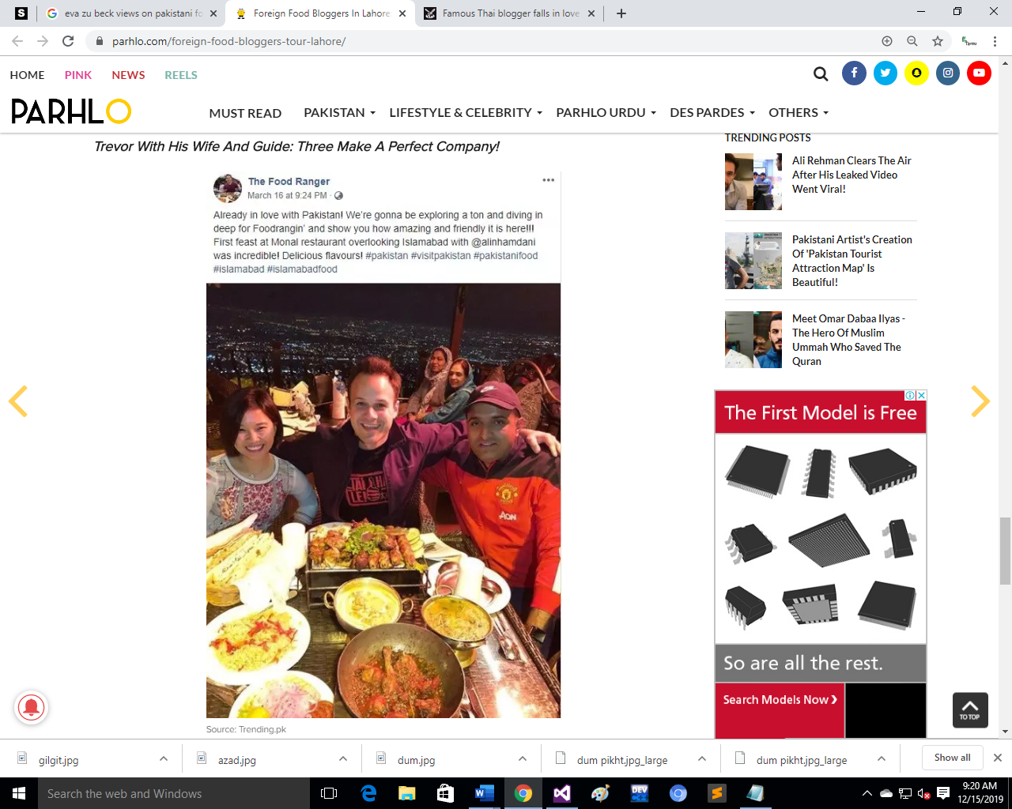

**Trevor Trevor With His Wife**

**According to Trevor,**

**“Pakistan is an amazing country and a beautiful destination for travel and food lovers.”**

**“Pakistan is the land of hospitality!!! We’ve been here one week now and have fallen in love with the delicious food.”**

**What Trevor was swift to mention was the fact that the couple never had to pay for anything they stopped by and a go at it. Such hospitable and friendly he found the people of Pakistan. Even his wife couldn’t silence herself for long. She also shared her good times here, remarking that people were welcoming and always smiling at them. In her words,**

**“The amount of flavor and spice in every bite has us in heaven.”**

**Trevor James Seen Here With His Favorite Foods: Leaving No Stones Unturned!**

**Not only these vloggers mentioned there are other more who had visited Pakistan just only for Food and its Beauty. Many are making their plains to visit Pakistan and really wants to taste Pakistani Cuisine.**